**DEEP LEARNING MODEL FOR DETECTING DISEASES IN TEA LEAVES**

*Artificial Intelligence (Naan Mudhalvan) report*

Submitted by

**JINO.I(960120243011)**

**HELAN MARY.E(960120243009)**

**NINISHA.L(960120243021)**

**MOHINI.N(960120243020)**

In partial fulfilment for the award of the degree of

**BACHELOR OF TECHNOLOGY**

In

**ARTIFICIAL INTELLIGENCE AND DATA SCIENCE**



**ANNAI VAILANKANNI COLLEGE OF ENGINEERING**

**BONAFIDE CERTIFICATE**

Certified that this report titled “**Deep learning model for detecting disease in tea leaves”** is the bonafide work of Jino.I(960120243011),Ninisha.L(960120243021),Mohini.N(960120243010) Helan mary.E(960120243009)who carried out the project work under my supervision. Certified further that to the best of my knowledge the wok herein does not from part of any project on the basis of which a degree was conferred on an earlier occasion on this or any candidate.

SIGNATURE SIGNATURE

Head of the department Staff-in-charge

INTRODUCTION

Deep learning has brought tremendous improvements in the recognition accuracy of image classification and object detection systems. plant diseases using accurate or automatic detection techniques can enhance the quality of food production and minimize economic losses. plant diseases using accurate or automatic detection techniques can enhance the quality of food production and minimize economic losses. Crop diseases are a major threat to food security, but their rapid identification remains difficult in many parts of the world due to the lack of the necessary infrastructure. The combination of increasing global smartphone penetration and recent advances in computer vision made possible by deep learning has paved the way for smartphone-assisted disease diagnosis. Using a public dataset of 54,306 images of diseased and healthy plant leaves collected under controlled conditions, we train a deep convolutional neural network to identify 14 crop species and 26 diseases (or absence thereof).

1.1.Project Overflow

* Develop an detecting disease using deep learning.
* Collect the disease dataset.
* Explore and select appropriate pre-trained deep learning model.
* Select the model.
* Evaluate and performance of the trained model using suitable metrics.

1.2.Purpose

Plant diseases and pests detection is a very important research content in the field of machine vision. It is a technology that uses machine vision equipment to acquire images to judge whether there are diseases and pests in the collected plant images. The proposed model using CNN was trained using images from plant village dataset and attained an accuracy of 94.87% in identifying the diseased plants with the help of image processing by OpenCV. Finally, the paper showcases the detailed analysis of the proposed scheme and results obtained by the model.

**2.IDEATION & PROPOSED SOLUTION**

**2.1Problem statement:**

Detecting disease in tea crop using deep learning concept. Predict the disease using CNN algorithm ( Convolutional neural networks ).

Deep learning area of research to have great potential in terms of increased accuracy . visualization techniques to detect and classify the symptoms of tea leaves disease

**2.2.Proposed solution template:**

|  |  |  |
| --- | --- | --- |
| s.no | Parameter | Description |
| 1. | Problem statement | Detecting disease in tea crop using deep learning concept. Predict the disease using CNN algorithm ( Convolutional neural networks ).  Deep learning area of research to have great potential in terms of increased accuracy . visualization techniques to detect and classify the symptoms of tea leaves disease. |
| 2. | idea | Detecting disease is the technique or tool for identify the disease by CNN and give the result in visual. |
| 3. | Social impact | Detecting for classification is that is a model is trained will effectively serves as a model for visual world |

**2.3. Empathy map**

Use this framework to develop a deep, shared understanding and empathy for other people. An empathy map helps describe the aspects of a user’s experience, and pain points, to quickly understand your user’s experience and indset.

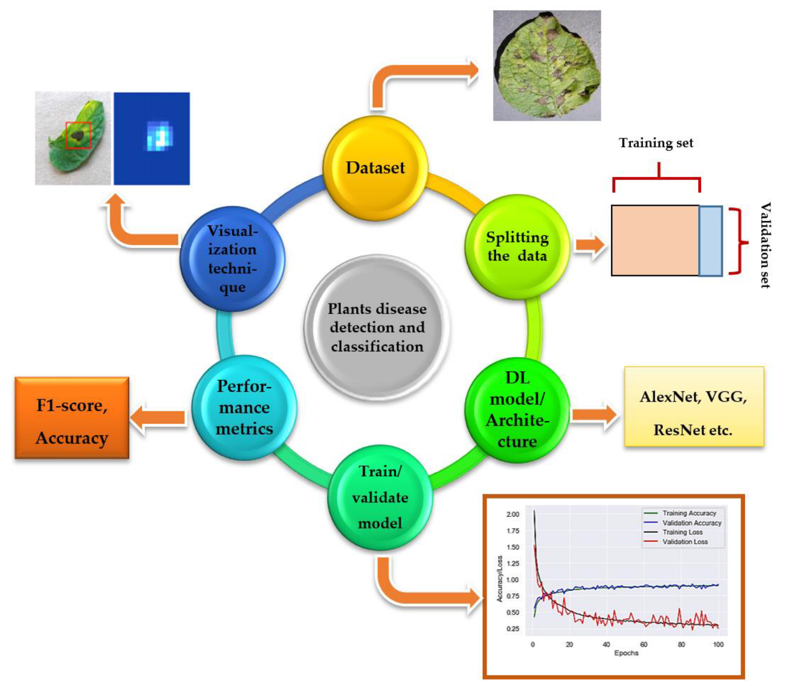

**2.4.Brainstorm:**

Brainstorming is a group problem-solving method that involves the spontaneous contribution of creative ideas and solutions. This technique requires intensive, freewheeling discussion in which every member of the group is encouraged to think aloud and suggest as many ideas as possible based on their diverse knowledge**.**

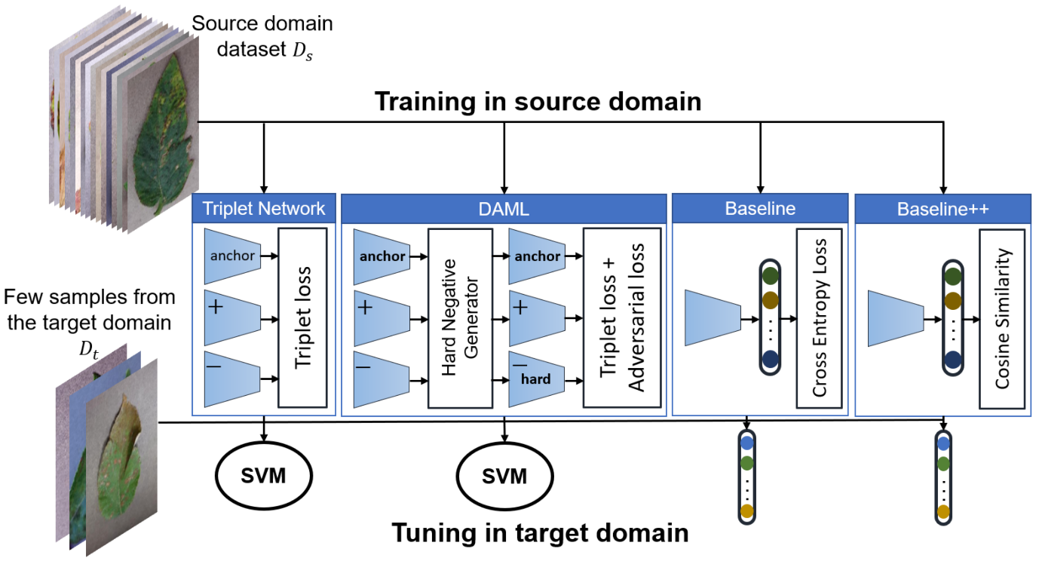

**3.PROJECT DESIGN**

**3.1**.Data flow Diagram:

A data flow diagram (DFD) maps out the flow of information for any process or system. It uses defined symbols like rectangles, circles and arrows, plus short text labels, to show data inputs, outputs, storage points and the routes between each destination.

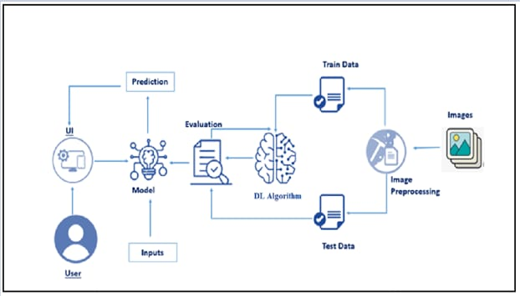

**Plant Disease Detection by Well-Known DL Architectures**

Many state-of-the-art DL models/architectures evolved after the introduction of CNN for image detection, segmentation, and classification. This section presents the researches done by using famous DL architectures for the identification and classification of plants’ diseases. Moreover, there are some related works in which new visualization techniques and modified/improved versions of DL architectures were introduced to achieve better results. Among all of them, the Plant Village dataset has been used widely as it contains 54,306 images of crops having 26 plant diseases . Moreover, they used several performance metrics to evaluate the selected DL models, which are describe

as below.

**4. ADVANTAGES AND DISADVANTAGES**

**Advantage:**

* Prediction accuracy is high and having robust working when training example have error in them.

**Disadvantages:**

* Require long training time. Difficult to understand learned function

5.**FUTURE SCOPE**

There are an increasing number of imaging and noninvasive sensors available that can support diagnosis and plant disease detec- tion. The progress in sensor and information technologies together with the expansion of geographic information systems opens new opportunities for precision agriculture and plant phenotyping**.**

**Types of disease affected in tea:**

Blister blight.

Red rust.

Brown blight, grey blight.

Twig die back, stem canker.

Brown root rot disease.

Red root rot disease.

Disease cycle.

IPM for Tea. 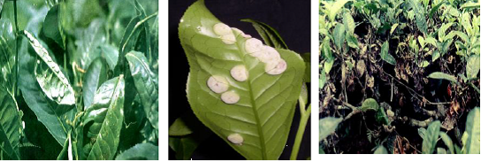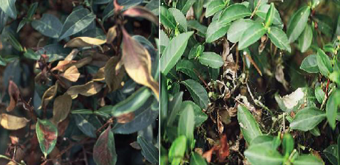

**Symptoms:**

1.Leaves develop lesions that are roughly circular, raised, and purple to reddish-brown. The alga may spread from leaves to branches and fruit.

2.Most algal spots develop on the upper leaf surface.

3.Older infections become greenish-gray and look like lichen. Cephaleuros usually does not harm the plant.

**1.Bounding box indicates the type of diseases**

